# **PEEE I Practical Session 3**

Ohm’s Law

________________________________________________________________________

**1. OBJECTIVES**

* To learn the proper use and connection of the variable dc power supply.
* To measure the dc voltage and dc current in a resistor using digital multimeters (DMMs).
* To verify that the ratio of voltage to current in a resistor follows Ohm’s law.

**2. EQUIPMENT**

* DC power supply.
* Digital Multimeters (DMMs).
* Training kit with a 2.2 kΩ resistor.

**3. PROCEDURE**

3.1 Keep the DC power supply remaining OFF.

3.2 Turn all knobs on the DC power supply fully counterclockwise to begin with minimum values.

3.3 Set the **Operation Mode** to **Independent** by releasing/extending the 2 push buttons in the middle of the power supply panel. This ensures that we have **2** independent output channels: CH1 and CH2.

3.4 Set the **CURRENT knob** approximately to the **9 o’clock position**. This limits the output current not to be too high.

3.5 Switch the DMM (**Ammeter**) to the **DC CURRENT mode**. See Figure 3.1. Ensure that the **red colour probe** is plugged into the **mA/μA socket**, and the **BLACK colour probe** is plugged into the **COM socket.**

3.6 Switch the DMM (**Voltmeter**) to the **DC VOLTAGE mode**. See Figure 3.2. Ensure that the **red colour probe** is plugged into the **‘V’ socket**, and the **BLACK colour probe** is plugged into the **COM socket.**

3.7 Connect the **red colour probe** of the **Ammeter** from the **mA/μA socket** to the **positive terminal (+)** of CH1 of the **power supply**. See Figure 3.3.

3.8 Connect the **black colour probe** of the **Ammeter** from the **COM socket** to a **2.2 kΩ resistor**.

This is the normal position of the circuit breaker switch.

If it extends up to break high current, disconnect the meter and press down the switch to resume operation.

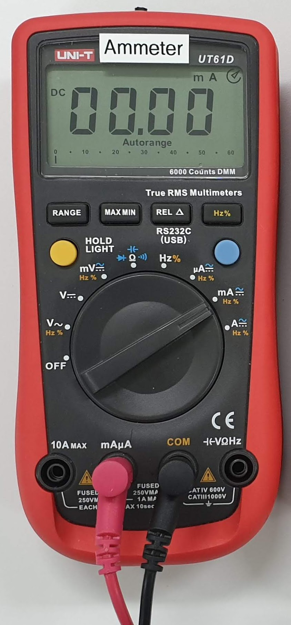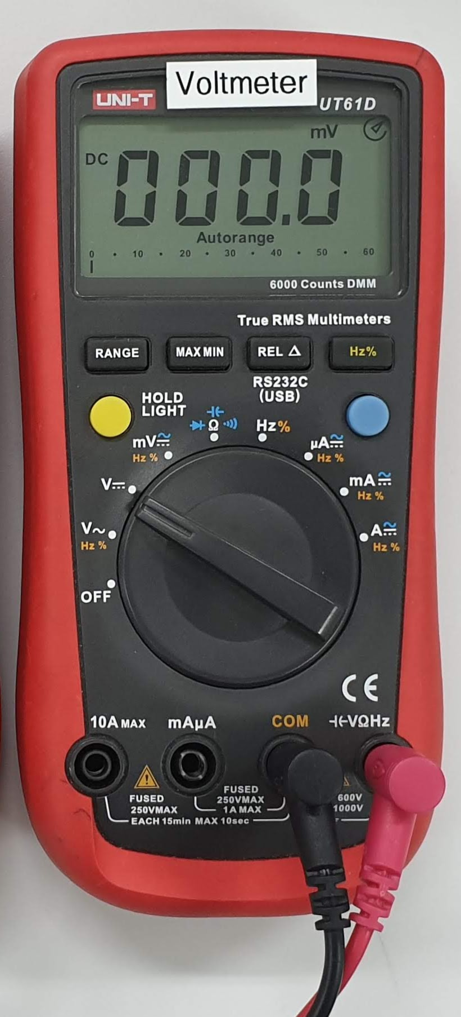

Figure 3.1 Use DMM as an ammeter Figure 3.2 Use DMM as a voltmeter

+

mA

+

−

2.2 k

+

V``

−

−

Figure 3.3 Circuit setup

12 V

10 V

⦁

⦁

⦁

0 V

HBL note: Construct the above circuit using Multisim as shown in Figure 3.3a.

(You may either explore Multisim on how to do it or follow the steps below to construct the circuit shown.)

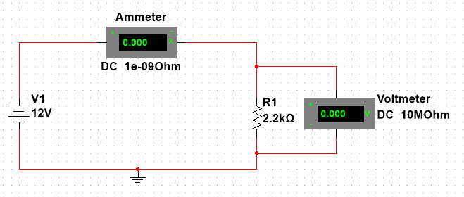

Fig 3.3a

1 Launch Multisim.

2 Select Place | Component from the menu. (This is the Component Browser.) The Component Browser is used to select components for placement onto the schematic.

3 This schematic needs the following components from the Master Database.

1. **Resistors** from the **Basic** Group.
2. Ground from the **Sources** Group > **POWER_SOURCES** > **GROUND**
3. DC supply from the **Sources** Group > **POWER_SOURCES** > **DC_POWER**
4. Voltmeter U1 from the **Indicators** Group> **VOLTMETER > VOLTMETER_V**
5. Ammeter U2 from the **Indicators** Group> **AMMETER > AMMETER_H**

You should get something like Fig 3.3b

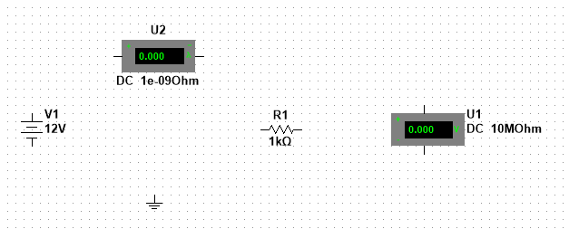

Fig 3.3b

4a You can change the property of the component by selecting the component (left click the mouse) and then right click the mouse and select Properties. You may need to rotate some of the components for a preferred placement position. This can be done by selecting the component and then right click on the mouse.

4b Right click on the Resistor and select Rotate 900 clockwise.

You should get something like Fig 3.3c

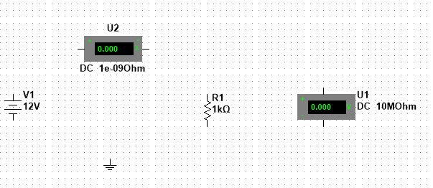

Fig 3.3c

5 Now, you need to connect the components together to form the circuit. Place the cursor at the pin of the components and the cursor will turn into a cross and drag it to the other end of the component to be connected.

You should get something like Fig 3.3d

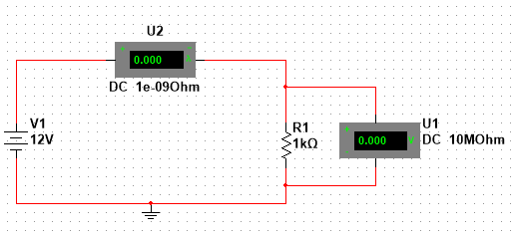

Fig 3.3d

6 In Fig 3.3d, U1 is the Voltmeter and U2 is the Ammeter. So let us make some changes to make this clear.

6a Double click on U1 and select the Label tab. Change the RefDes from U1 to Voltmeter.

6b Double click on U2 and select the Label tab. Change the RefDes from U2 to Ammeter.

7 The resistor is supposed to be 2.2 k But the wrong value of 1 k was selected earlier.

7a Double click on the resistor and select the Value tab. Change the resistance to 2.2 k from the range of values.

You should get something like Fig 3.3e



Fig 3.3e

8 Select Simulate | Run to start the simulation. Record the value of the current in Table 3.1

9 Change the value of supply voltage and fill up Table 3.1.

**Note that the part in green (for HBL) replaces 3.1 to 3.11 of this Practical. You still have to do 3.12 onwards, using the data from Mutlisim.**

3.9 Complete the circuit connections in Figure 3.3.

**NOTE:** (1) To measure the current in a resistor, connect a current meter in series with the resistor. (2) To measure the voltage across a resistor, connect a voltmeter in parallel with the resistor.

**NEVER** connect a **current meter** in **PARALLEL** with a device, such as a power supply or a resistor.

3.10 Switch on the power supply, and turn the VOLTAGE knob to increase $V_{R}$ (Voltmeter reading) to 12 V or almost 12 V. Record the voltmeter reading and the ammeter reading to all significant digits.

3.11 Repeat with the other voltages to complete Table 3.1.

|  |  |  |
| --- | --- | --- |
| **Resistor** | $V_{R}$**(V)** | **(mA)** |
| 2.2 k | 12 V |  |
| 2.2 k | 10 V |  |
| 2.2 k | 8 V |  |
| 2.2 k | 6 V |  |
| 2.2 k | 4 V |  |
| 2.2 k | 2 V |  |
| 2.2 k | 0 V |  |

3.12 Plot $V_{R}$ against $I_{R}$. Draw a **straight line** of **best fit** passing through the **origin** (zero).

$V_{R}$ (V)

12

$I_{R}$ (mA)

0

1

2

3

4

5

10

8

6



4

2

6

## Table 3.1

3.13 The graph of $V_{R}$ against $I_{R}$ should be a straight line passing the origin (0 V, 0 mA). $V_{R}=mI_{R}$, where $m=$ gradient of the straight line $=$ (resistance by definition).

Find out **from the straight line** on the graph (**NOT** from the data in **Table 3.1**),  
when $V_{R}=11 V$, $I_{R}= ?A$, and when $V_{R}=10 V$, $I_{R}= ?A$.

____________________________________________________________________________

____________________________________________________________________________

Follow the steps below to calculate the gradient or the resistance. The two gradient answers should be the same if the graph could provide infinite resolution.

$$Gradient=Resistance=\frac{ΔV_{R}}{ΔI_{R}}=\frac{V_{R}-0 V}{I_{R}-0 A}=\frac{V_{R}}{I_{R}}=\frac{11 V}{?A}= ?$$

$$Gradient=Resistance=\frac{V_{R}}{I_{R}}=\frac{10 V}{?A}= ?$$

____________________________________________________________________________

____________________________________________________________________________

Using the gradient of the line of best fit to calculate a resistance can reduce the effect of voltage and current measurement errors.

3.14 **Disconnect the 2.2 k resistor** from the power supply and the ammeter. Use the **DMM with the label of Voltmeter to measure** and record the **actual resistance** of the 2.2 k resistor. Is the measured resistance equal to or very close to the gradient of the straight line?

____________________________________________________________________________

____________________________________________________________________________

|  |  |
| --- | --- |
|  | Do the results of the experiment follow Ohm’s Law, *V* = *IR*?  _____________________________________________________________  _____________________________________________________________ |

**4. CONCLUSION**

____________________________________________________________________________

____________________________________________________________________________

____________________________________________________________________________